Implement Programs For Visualizing Time Series Data
EX:No.2 DATE:01/02/25

AIM:
Write a program to implement programs for visualizing time series data.
ALGORITHM:

Step 1: Install and import required libraries (pandas, matplotlib, seaborn).

Step 2: Load sales data, parse dates, and set 'Order Date' as the index.

Step 3: Aggregate sales by date and handle missing/duplicate values.

Step 4: Extract 'Day of Week' and 'Month' from 'Order Date'.

Step 5: Generate visualizations.

Step 6: Add labels, titles, and display plots.

CODE:

import matplotlib.pyplot as plt

import seaborn as sns

import pandas as pd

data = pd.read_csv("D:\\TSA Lab-1\\cinemaTicket_Ref.csv")

sns.set_style("whitegrid")

cinema_sales = data.groupby('cinema_code')['total_sales'].sum().reset_index()

plt.figure(figsize=(8, 4))

sns.barplot(x='cinema_code', y='total_sales', data=cinema_sales, hue='cinema_code', palette='viridis', dodge=False, legend=False)

plt.title('Total Sales per Cinema', fontsize=16)

plt.xlabel('Cinema Code')

plt.ylabel('Total Sales')

plt.xticks(rotation=45)

plt.show()

data['date'] = pd.to_datetime(data['date'])

occupancy_time = data.groupby('date')['occu_perc'].mean().reset_index()

plt.figure(figsize=(8, 4))

sns.lineplot(x='date', y='occu_perc', data=occupancy_time, marker='o', color='b')

plt.title('Occupancy Percentage Over Time', fontsize=16)

plt.xlabel('Date')

plt.ylabel('Occupancy Percentage')

plt.show()

plt.figure(figsize=(8, 4))

sns.histplot(data['tickets_sold'], bins=20, kde=True, color='g')

plt.title('Distribution of Tickets Sold', fontsize=16)

plt.xlabel('Tickets Sold')

plt.ylabel('Frequency')

plt.show()

plt.figure(figsize=(8, 4))

sns.boxplot(x='month', y='ticket_price', data=data, palette='coolwarm')

plt.title('Variability in Ticket Prices by Month', fontsize=16)

plt.xlabel('Month')

plt.ylabel('Ticket Price')

plt.show()

OUTPUT:
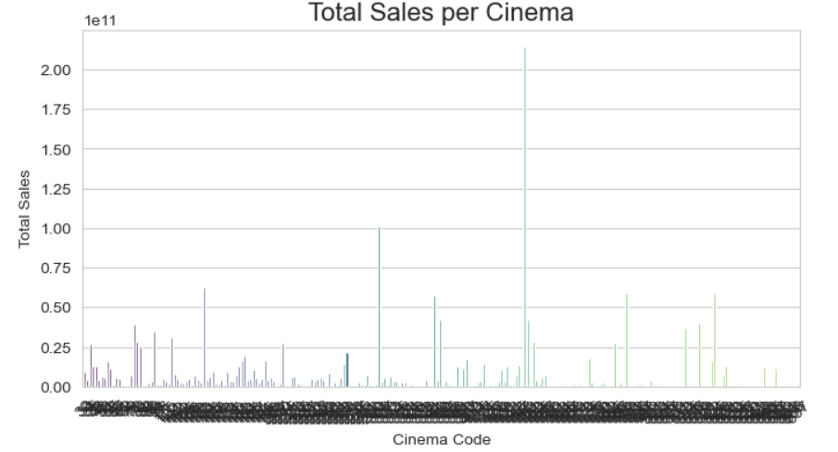

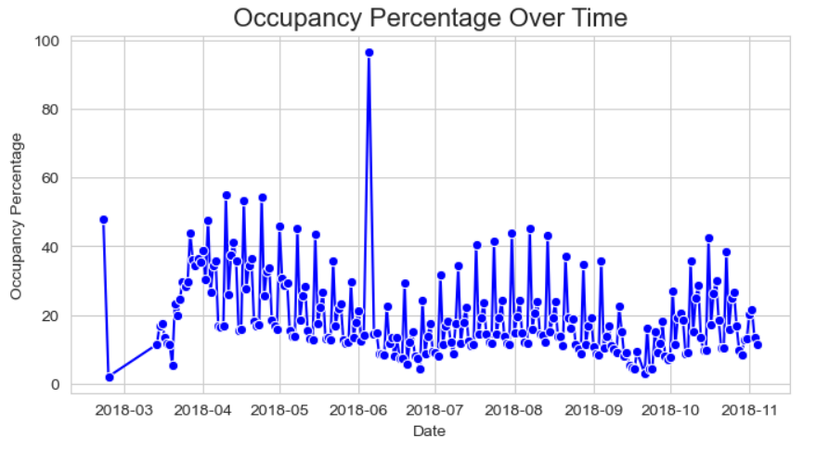

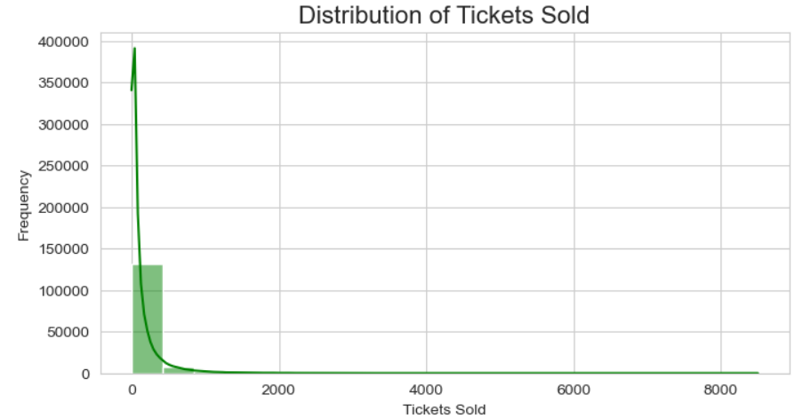

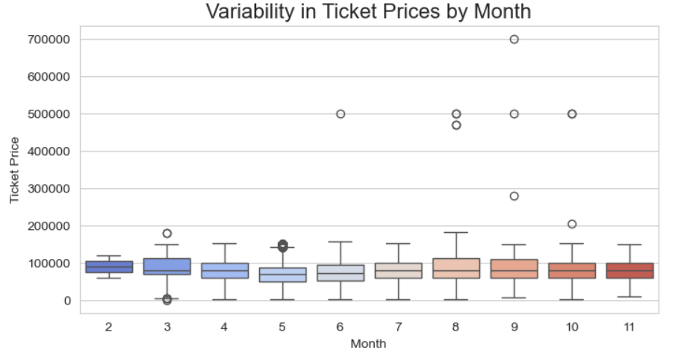

RESULT:
Thus, the program using the time series data implementation has been done successfully.

